Course Name:  Course Code: | Basic of Electrical Engineering BEEL)  316U06L102 | Semester: | I
Date of Performance: | / / 20-- | Batch No:
Student Name: |  | Roll No:
Faculty Sign & Date: |  | Grade/Marks: | / 20

Experiment No: 4

Title: Maximum Power Transfer Theorem

Aim and Objective of the Experiment:
- To observe maximum power transfer across load resistor in a D.C circuit.

COs to be achieved:
CO1: Analyze resistive networks excited by DC sources using various network theorems.

Circuit Diagram:
V_{S} = 15 V and R_{S} = _____ Ω

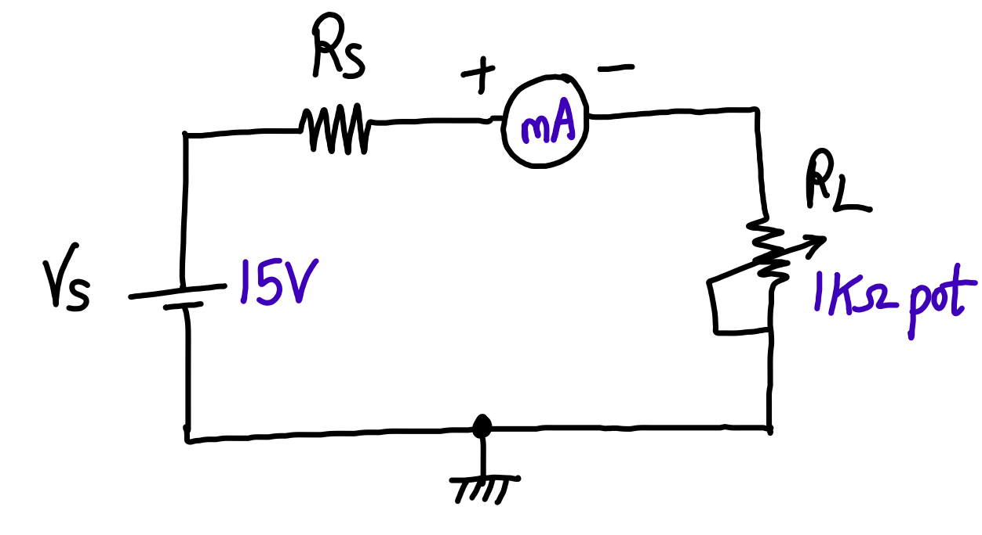

Stepwise-Procedure:
1. Set D.C. supply voltage V_{S} = 15 V
2. Vary $R_{L}$ in the range 100 Ω - 1 KΩ in steps of 100 Ω
3. Note down $I_{L } and V_{L}$ for each value of $R_{L}.$ Where $I_{L }and V_{L}$ are current through $R_{L}$and
voltage across $R_{L}$ respectively.
4. Prepare observation table showing readings of $R_{L} Vs power P$ $= I_{L }$ . $V_{L}$
5. Plot graph of $P Vs R_{L}$
6. Locate the point of maximum value of power $P$and note down corresponding value of $R_{L}.$
Verify the results theoretically

Observation Table:
Sr. No. | R_{L} Ω | Circuit Current (I_{L}) in mA |  | Voltage (V_{L}) in Volts | Power absorbed by load (P_{L}) in W  P_{L} = I_{L}².R_{L}
 |  | Theoretical | Practical |  | Theoretical | Practical
 | 100
 | 200
 | 300
 | 400
 | 500
 | 600
 | 700
 | 800
 | 900
 | 1 K

Graph: Draw a graph showing effect of variation in R_{L} on P_{L} using observation table. Take R_{L} on X –axis and P_{L} on Y- axis. (Use a graph paper)

Conclusion-
- Explore one practical application where Maximum Power Transfer Theorem is used.
- Draw a block diagram or circuit diagram of this application.
- Explain in brief.
OR
Answer the following:
- Do you apply Thevenin’s Theorem to calculate Maximum Power across load resistor in a D.C. circuit?
- Take a sample problem. Draw a block diagram or circuit diagram of this sample problem.
- Explain the solution in brief.

Signature of faculty in-charge with Date:

